**INDIAN INSTITUTE OF TECHNOLOGY KHARAGPUR**



Department of Electronics & Electrical Communication

Engineering

M.Tech. First Year

EC60064: Biomedical System Engineering and Automation

Assignment No.2

Submitted by

Suraj Kumar (22EC65R14)

Experiment 1:

The files 1-xx.dat, where xx indicates the channel name, give eight simultaneously recorded channels, having sampling rate of 102 Hz per channel, of EEG signals with the alpha rhythm. To use as a reference signal, remove a section of the signal that clearly has the alpha rhythm. Cross-correlate the reference signal with multiple channels' running windows, then study the use of the results to identify the presence of the alpha rhythm. (Hint : Alpha rhythm is from 3 to 4 sec)

Result:

The image below shows the 8 channel data, the sampling rate is 102Hz so in 1 second there are 102 data, so since the alpha rhythm from 3 to 4 second. Therefore the data is from 306 to 408 which is clearly visible in 2nd and 7th waveform, So we have chosen the channel 2 as the alpha wave

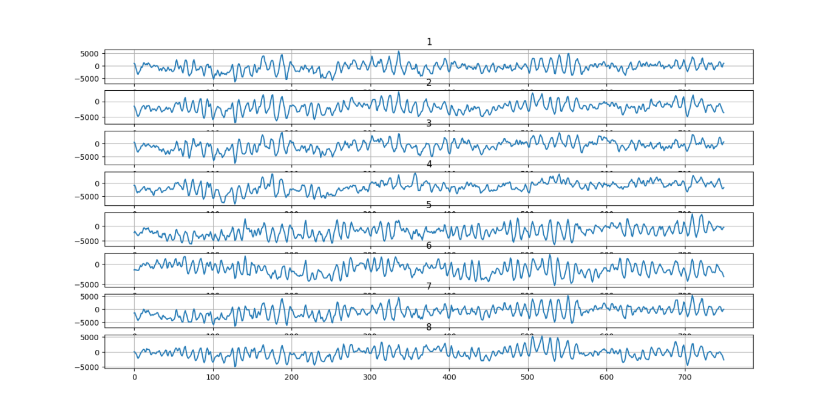

And after cross-correlation with that alpha signal window to each of the channel, We get the image as shown below for each of the channel, there are peaks, these peaks depicts the presence of alpha wave in those channels

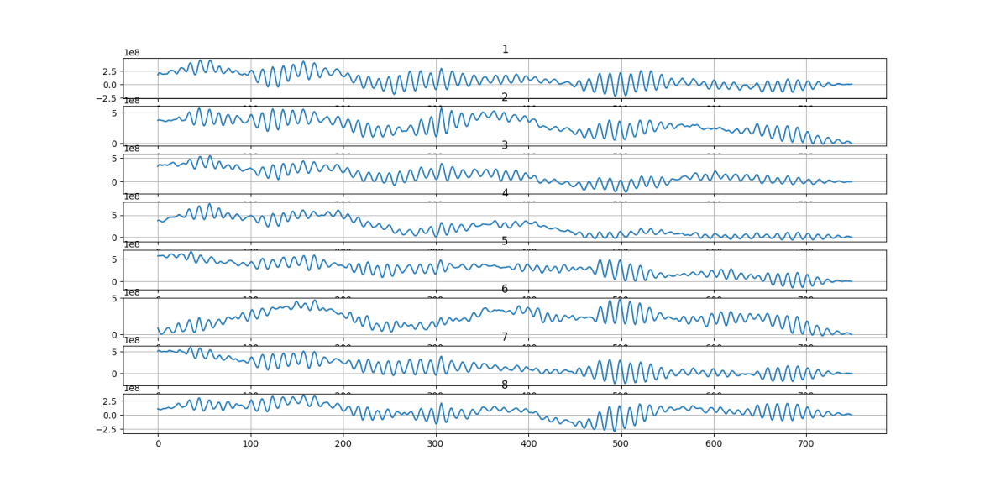

Experiment 2:

The three-channel recordings of the PCG, ECG and carotid signals, sampled at 900 Hz are given in the files 21.dat, 22.dat, and 23.dat respectively. The signals in 21.dat and 23.dat are normal and 22.dat has the PCG signal having systolic murmur and is of a patient suspected to have pulmonary stenosis, ventricular septal defect, and pulmonary hypertension. Use the Lehner and Rangayyan approach to find the dicrotic notch in the carotid pulse channel and the Pan-Tompkins method to find the QRS in the ECG channel. Extrapolate the timing information from the ECG and carotid pulse channels to detect the onset of s1 and s2 in the PCG channel.

Result:

The image below shows the 3 channel data for each of the patients:

For Person1 (21.dat)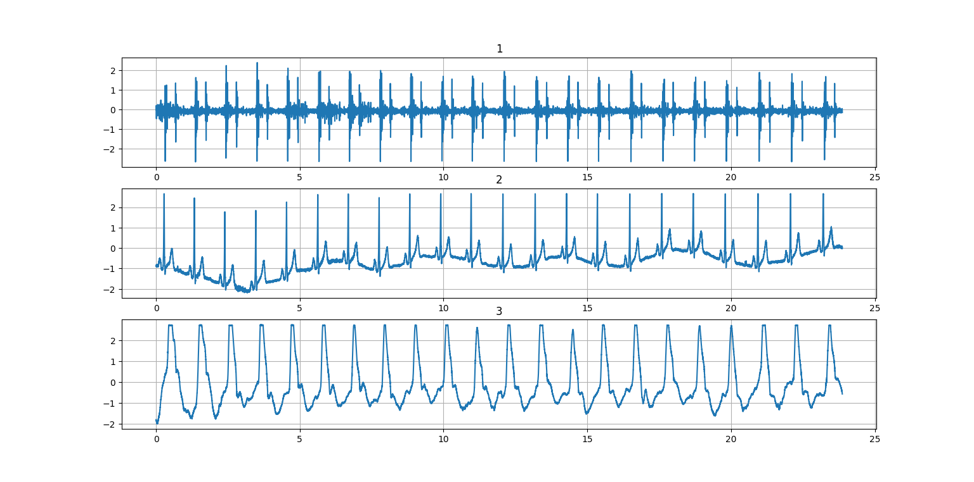

For Person2 (22.dat)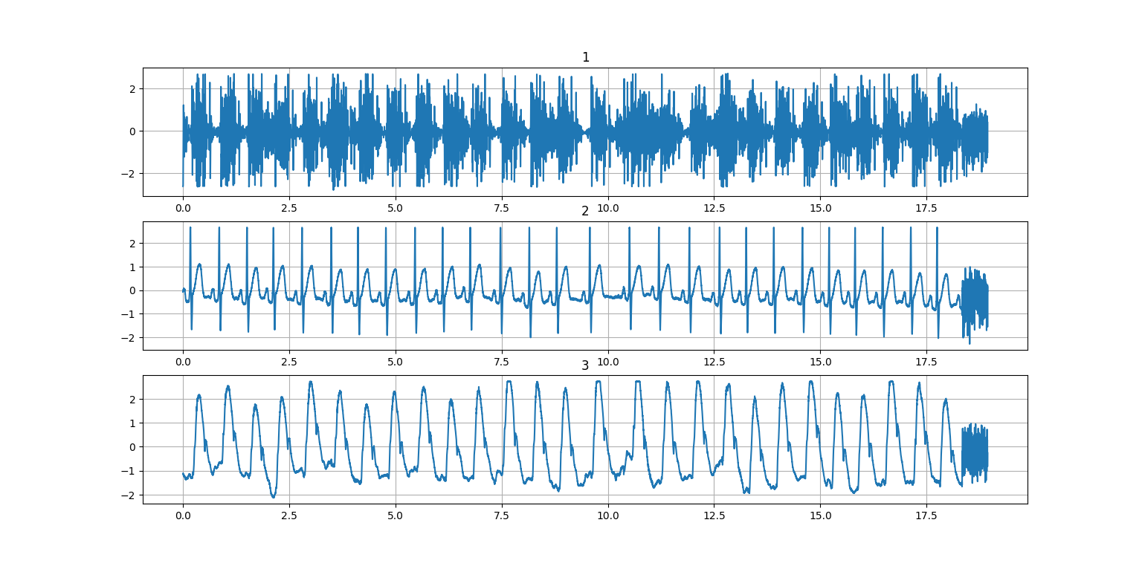

For Person3(23.dat)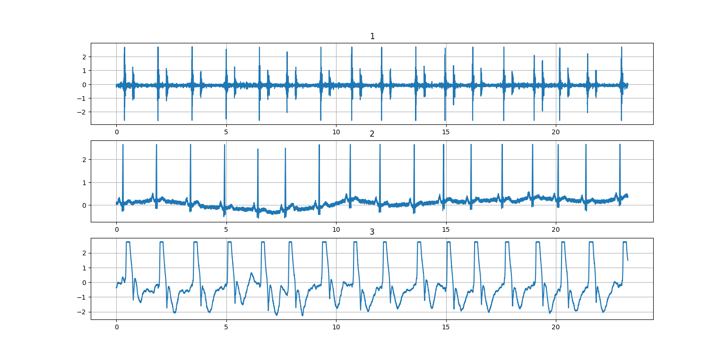

For getting the dicrotic notch, we sliced the signal from 1000 to 5000 samples and the results come out as:

For 1st data :

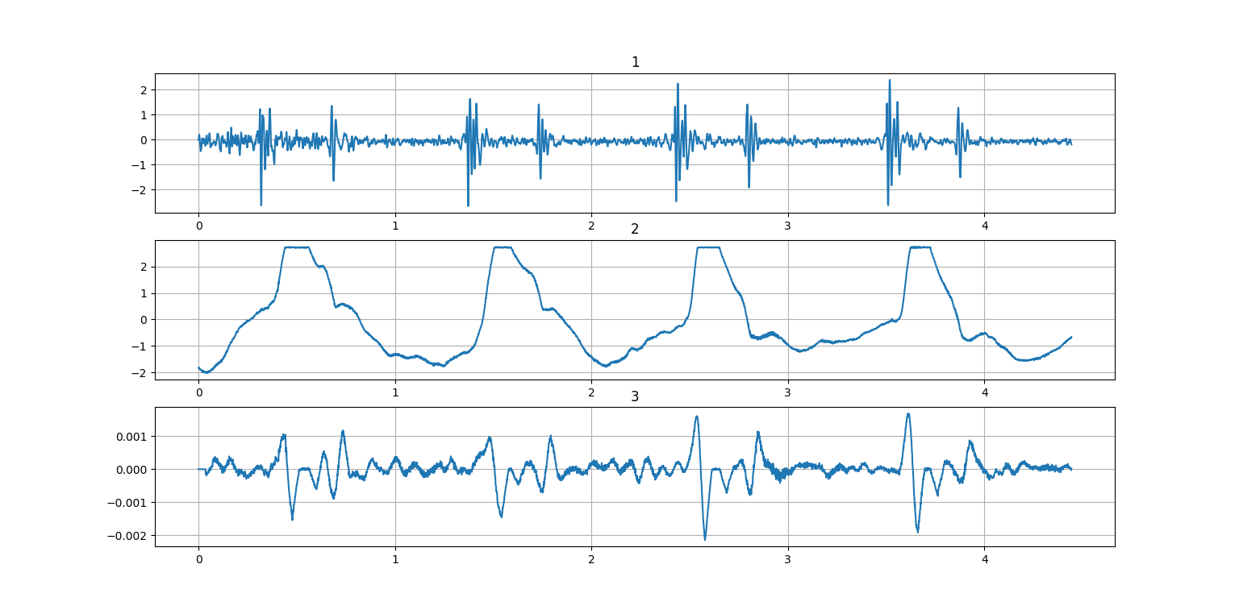

For 2nd data set 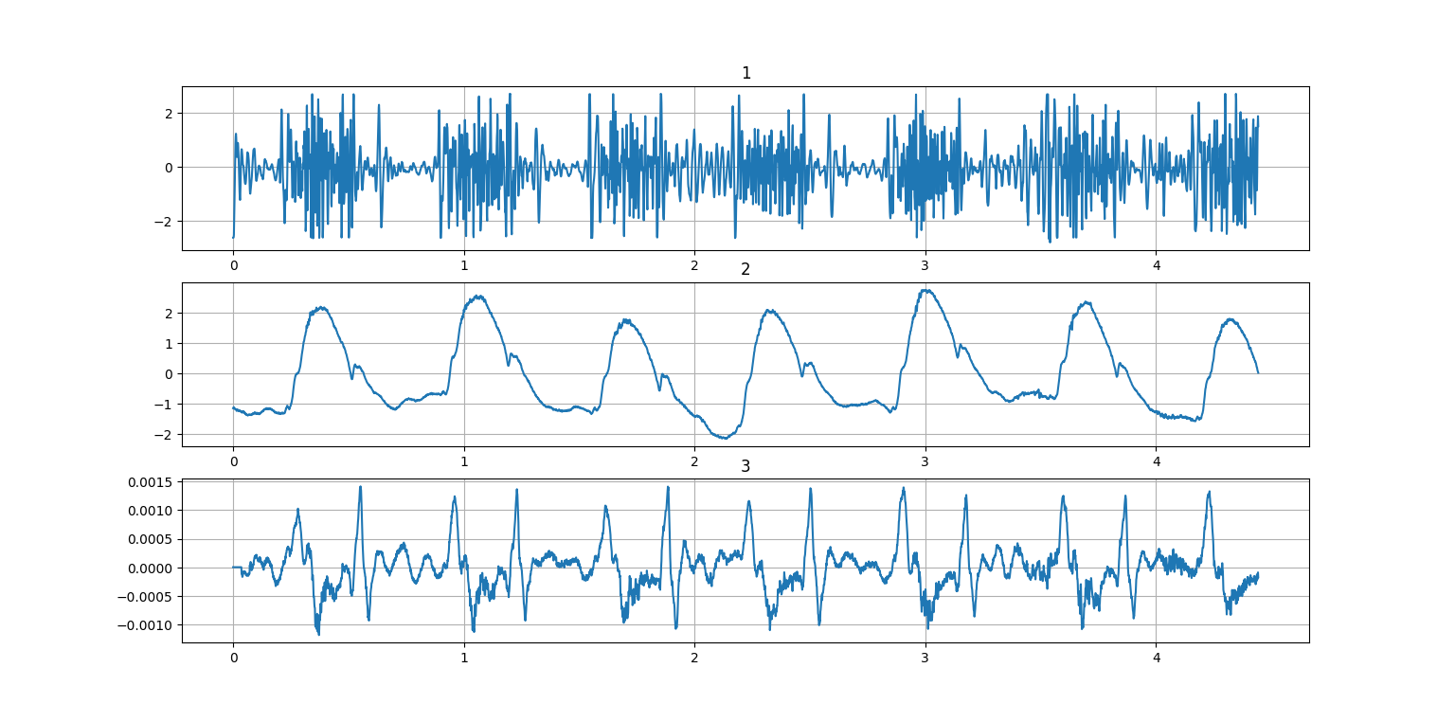

And from 3rd data set 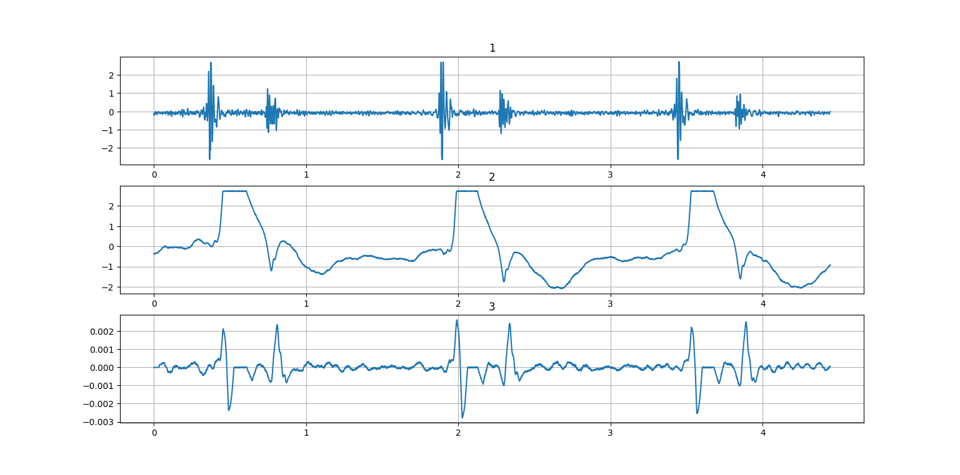

Where the 1st channel of each graph is for PCG signal, the 2nd one is carotid signals and the 3rd one is signal obtained using Lehner and Rangayyan approach, clearly the second peak denotes the presence of dicrotic notch

PAN-TOMPKIN METHOD: applying on the second signal we get

1. The original signal of 900 Hz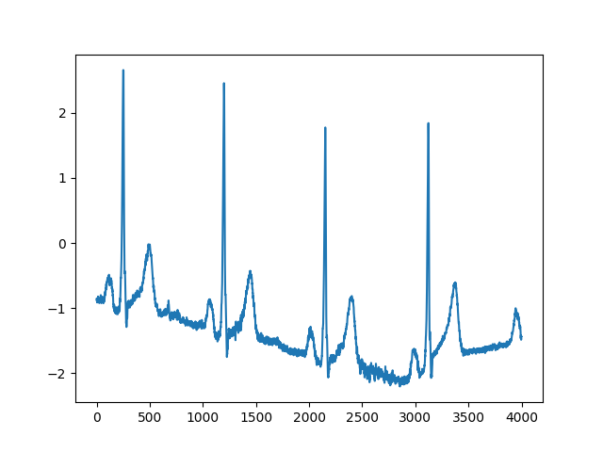
2. The Signal after sampling it back to 200Hz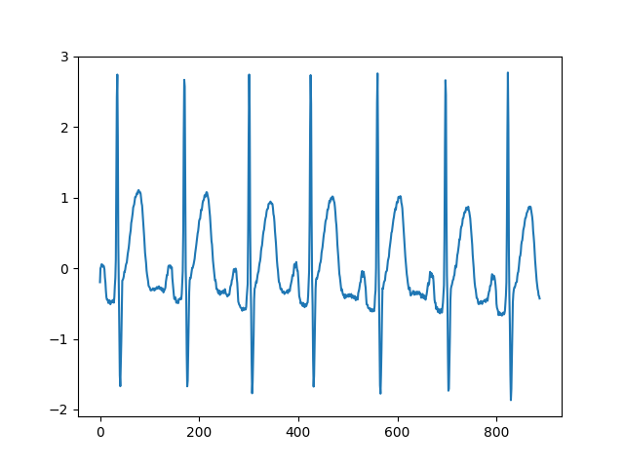
3. Low pass filter
4. 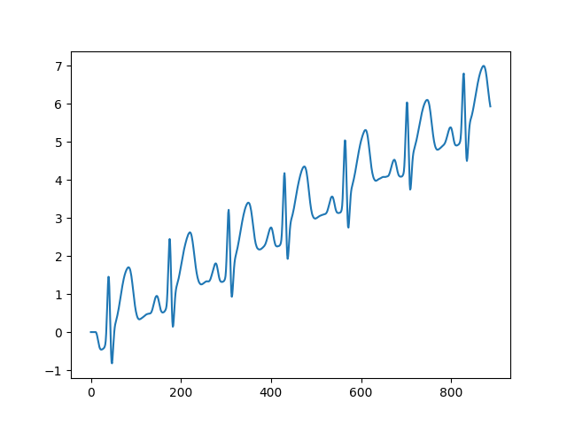
5. High pass filtering
6. 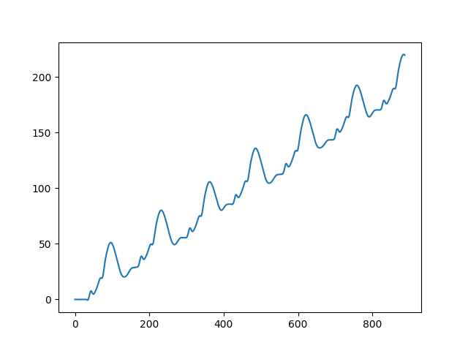
7. Difference equation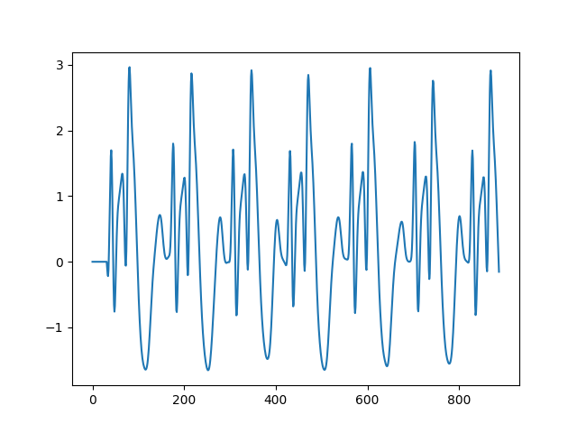
8. Squaring 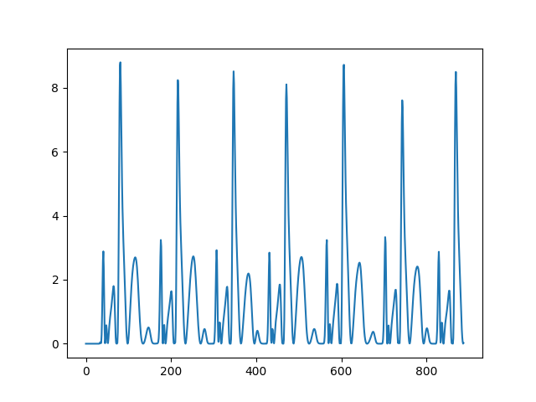
9. MA Integration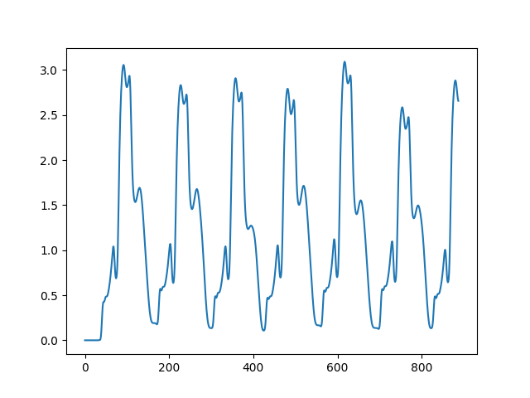

So when we check the local peak of the graph output from pan-tompkin method output :

Clearly the peak(orange) overlap with QRS peak (blue)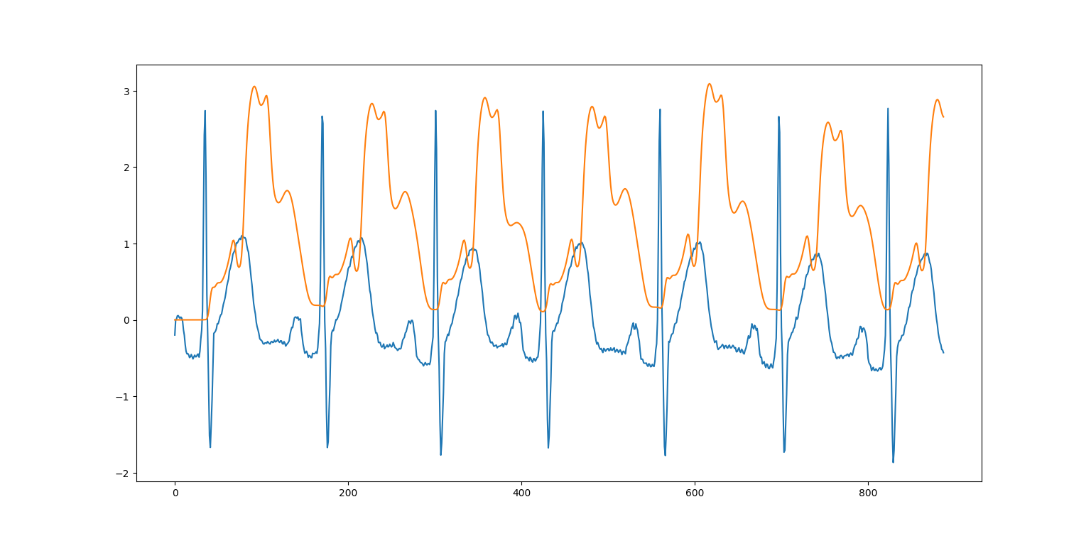

Hence, S1 and S2 can be found as shown in the figure

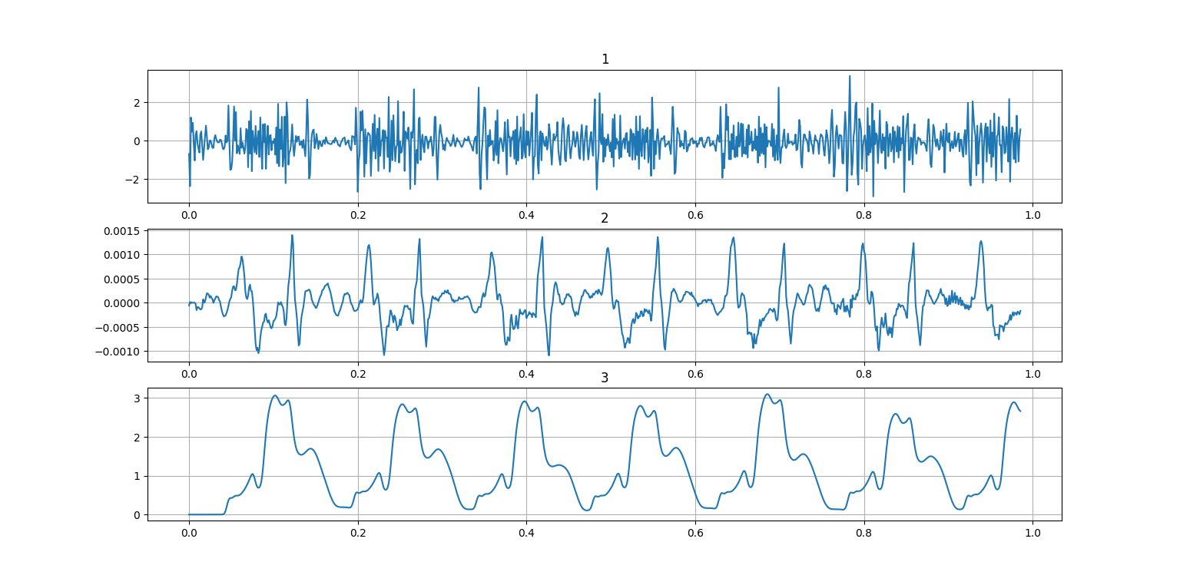

Where the 1st channel is the PCG signal the 2nd channel gives the S2 value as every 2nd local peak and S1 is given by the local peak in the 3rd channel coming from pan-tompkin algorithm

Doing adaptive filtering using *initial threshold value*th1 = 10  
th2 = 0.1  
npki = 0.5

We get th1 as 0.9628786428001337 and th2 as 0.48143932140006684

Experiment 3:

Consider two ECG signal files m_31.mat and m_32.mat having signals sampled at 200 Hz. Perform the following tasks sequentially in Python for both the signals and plot the signals after each operation.

1. Lowpass Filtering : Use an eighth-order Butterworth lowpass filter having cutoff frequency 11 Hz.
2. Highpass Filtering : Pass the output of the above operation to an eighth-order Butterworth high pass filter having cutoff frequency 5 Hz.
3. Derivative Operation : Pass the output of the above operation to the derivative operator specified below:

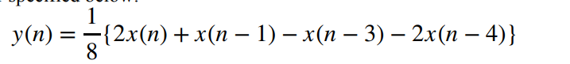

1. Squaring : Square the above obtained output.
2. Integration : Pass the output of the above operation to the integration operator specified below:



1. QRS Complex Detection : Detect QRS complexes in the above obtained output using a simple threshold-based method. Initially, take the threshold value equal to 95% of the maximum value of the output obtained from the last operation. Then, go on decreasing it and observe the changes in your result.
2. Heart Rate Calculation : Use the information of the above obtained output to calculate the average heart rate

**RESULTS:**

**For signal m_31 we get**

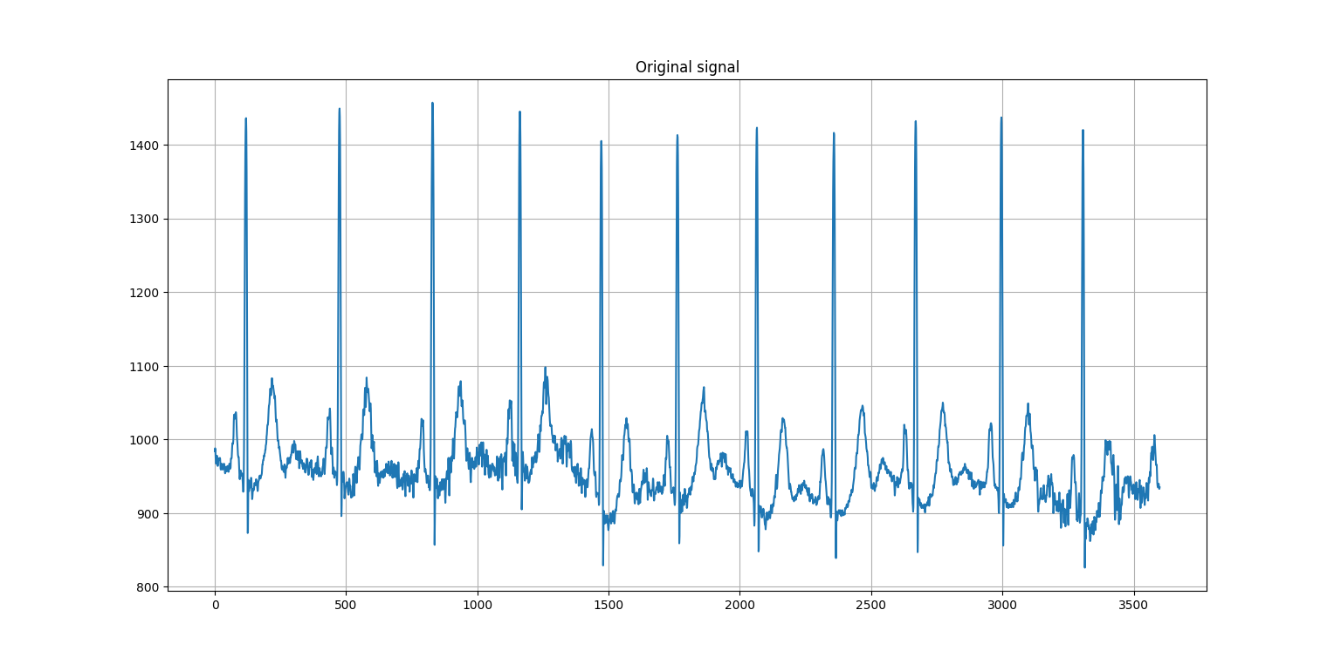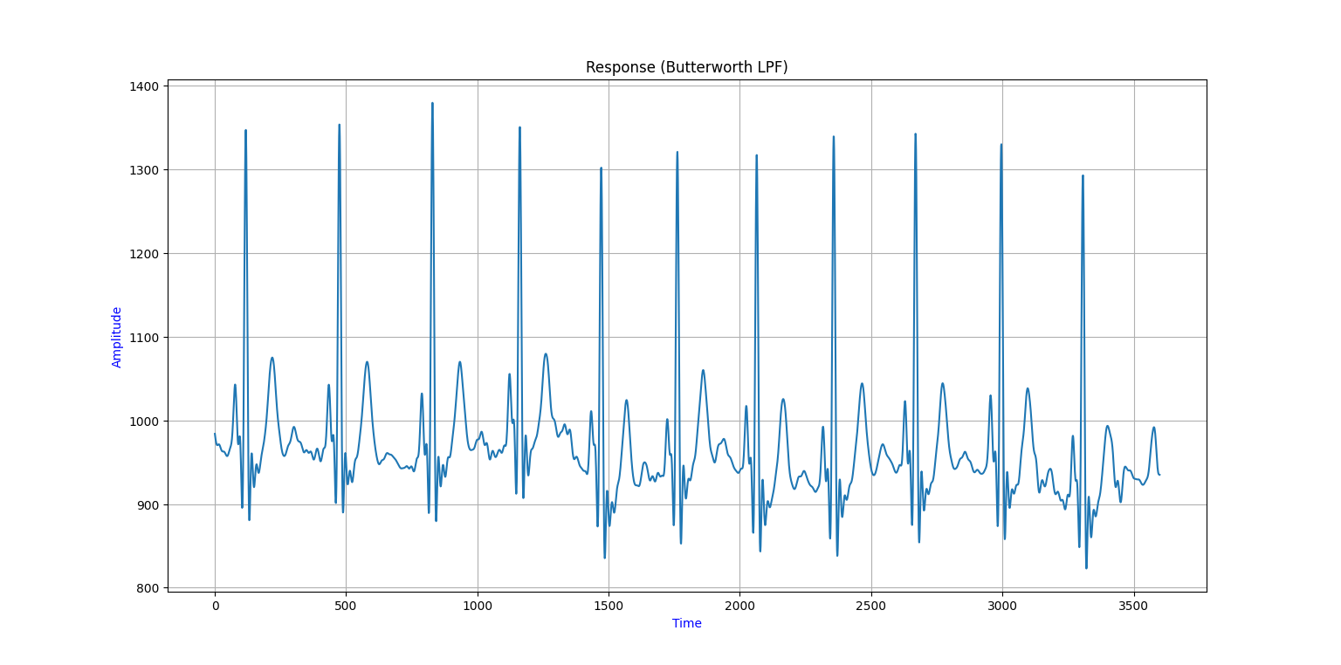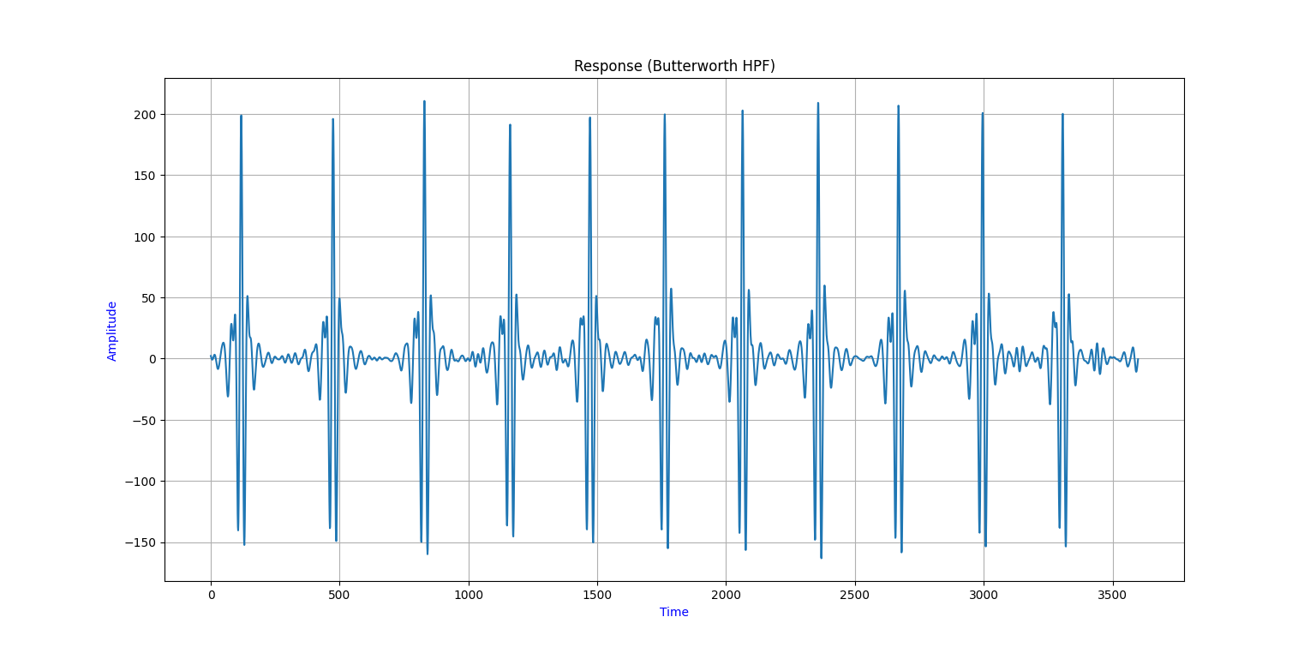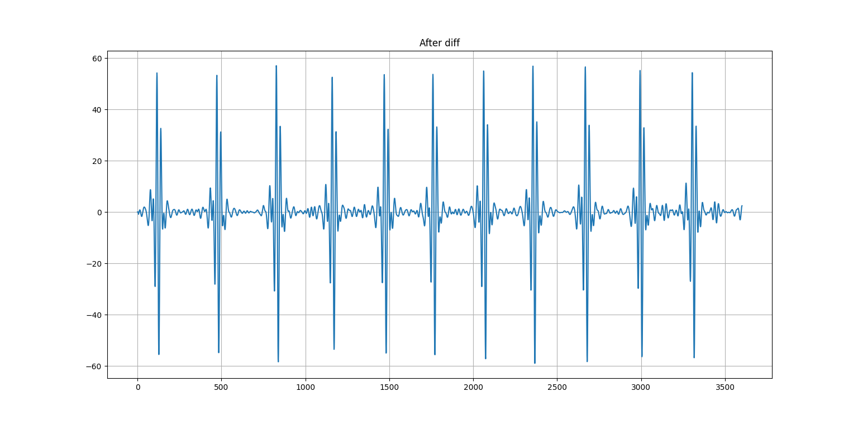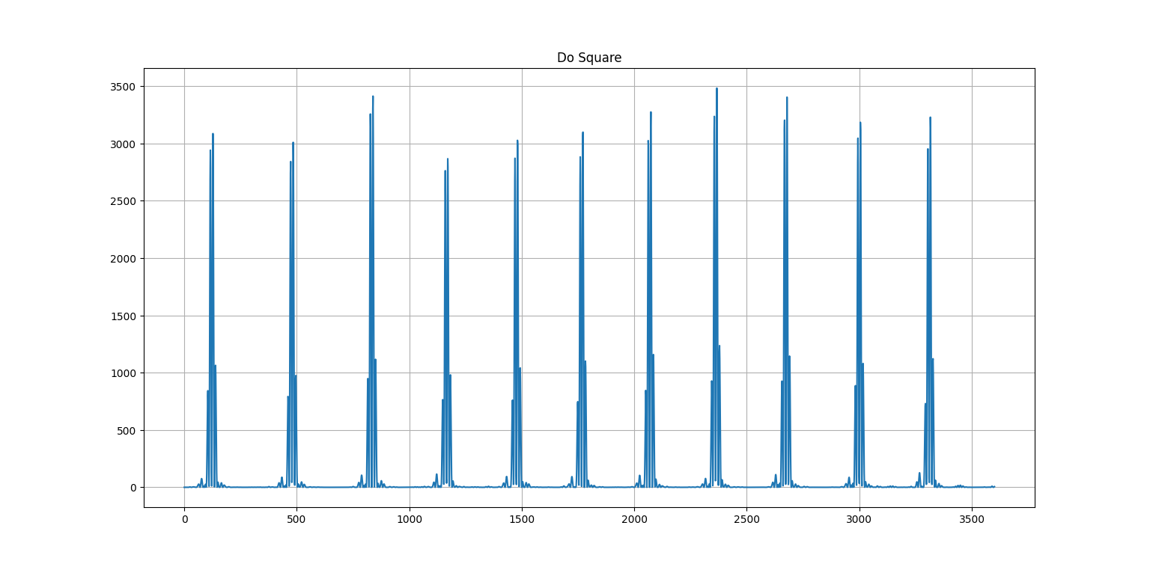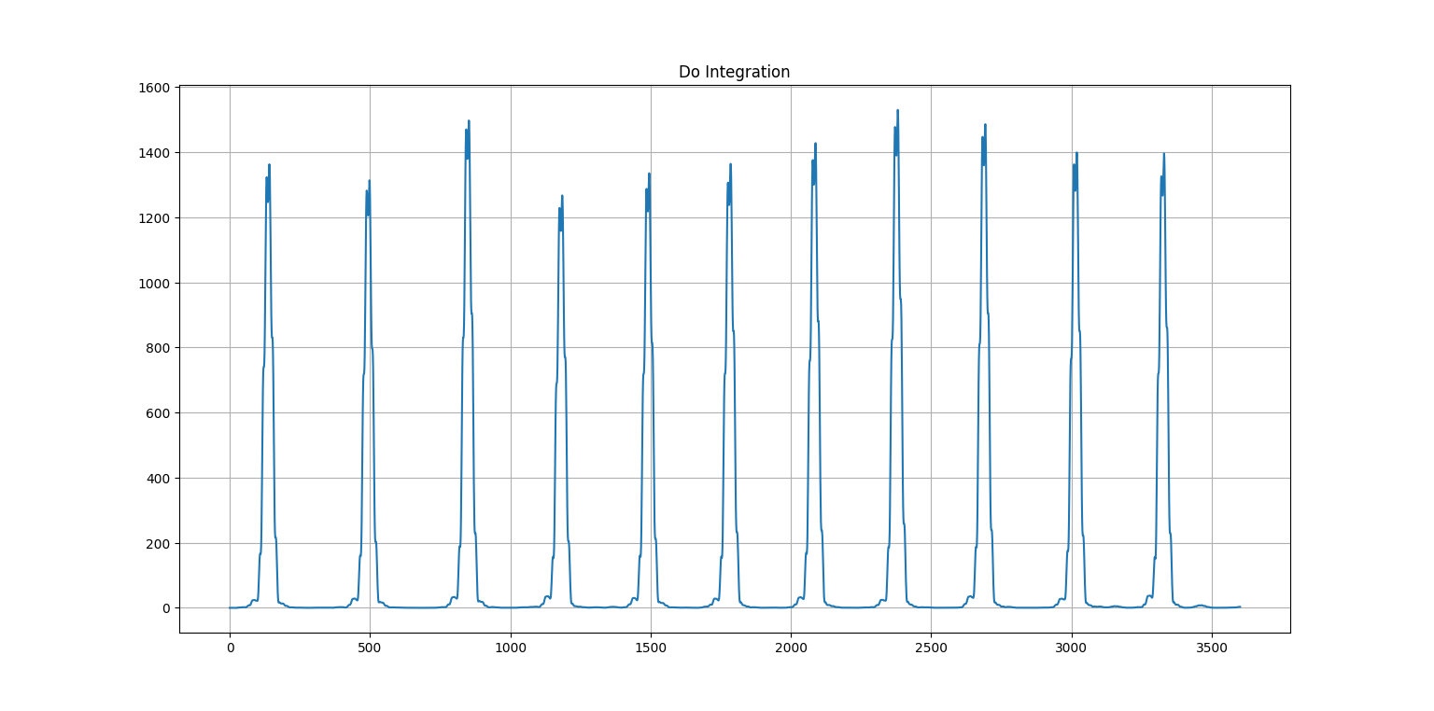

**Making the threshold of 0.95 of maximum peak we can detect only 3 ECG peak** 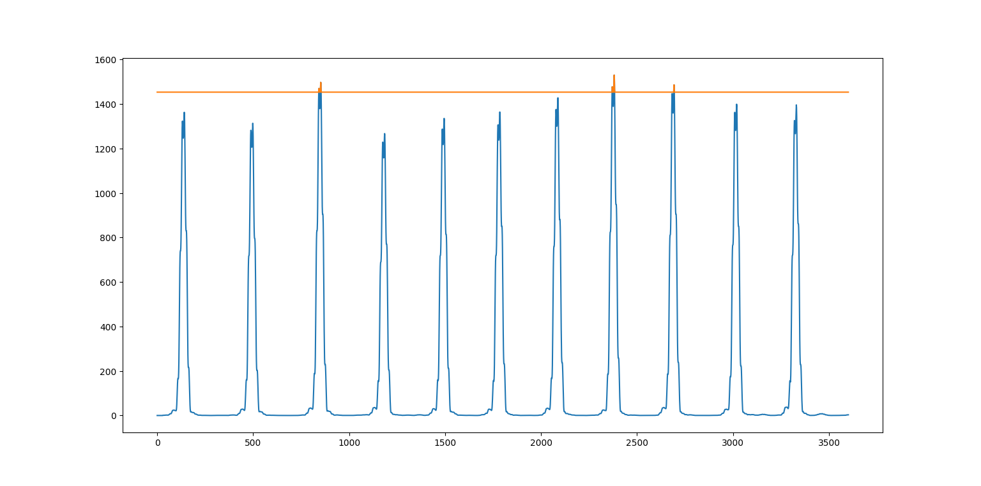

**But as we decrease the threshold by 0.9* max then, the number of peak detected becomes 4**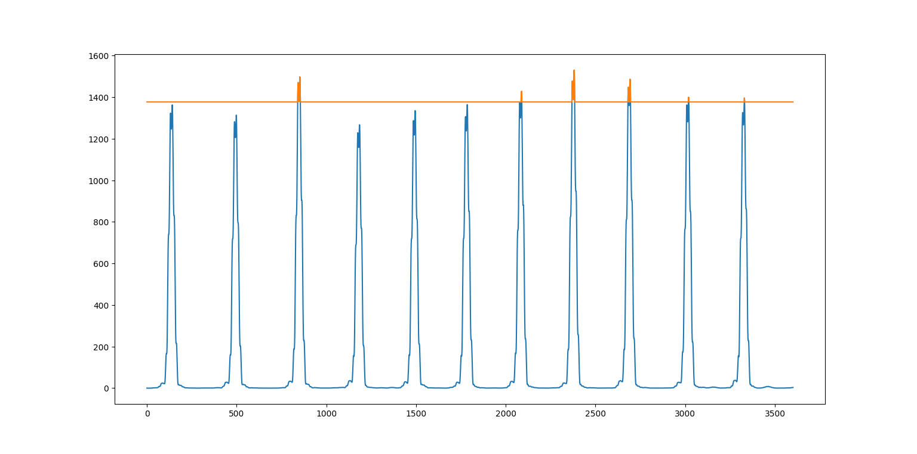

**And average heart rate by keeping the threshold as 0.5*max peak we get Heart rate: 75.25870178739417 ppm**

**For Signal m_32**

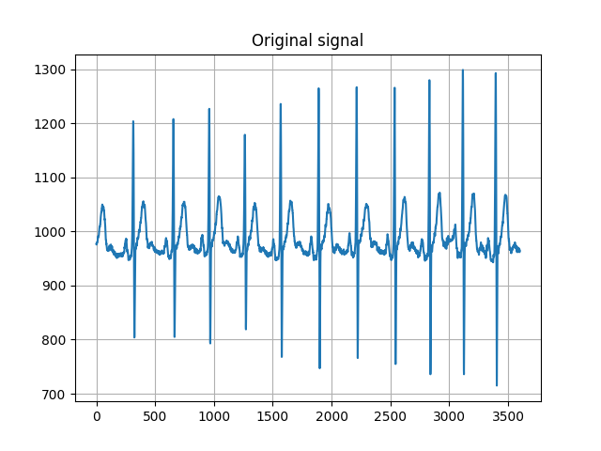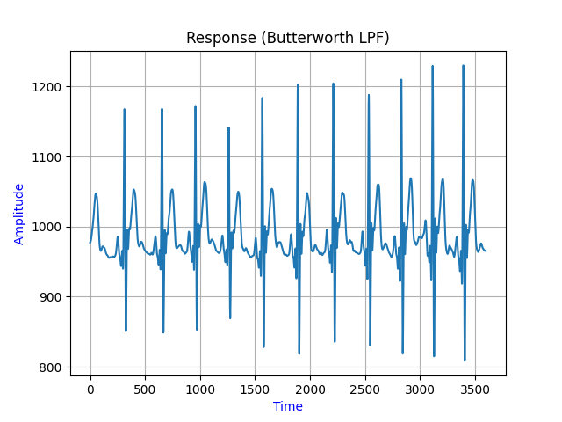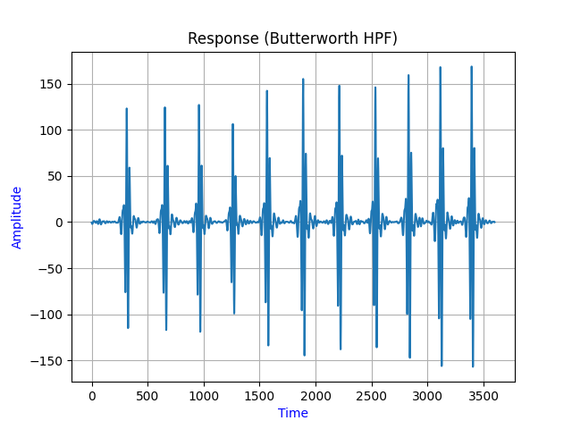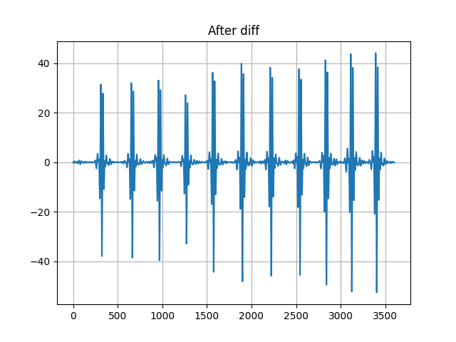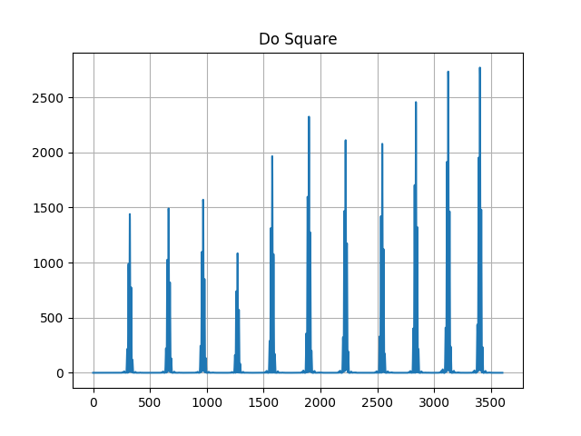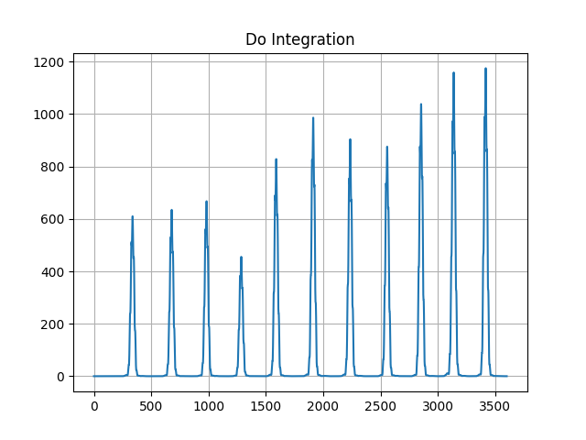

**Making the threshold of 0.95 of maximum peak we can detect only 2 ECG peak** 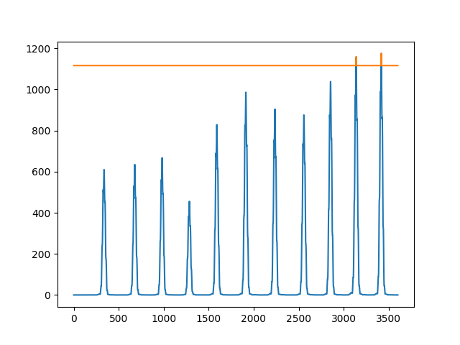

**When we decrease the threshold to 0.9*max peak then also we detect 2 ecg pulse. So we reduce the threshold more lower to 0.8* max peak then we get**

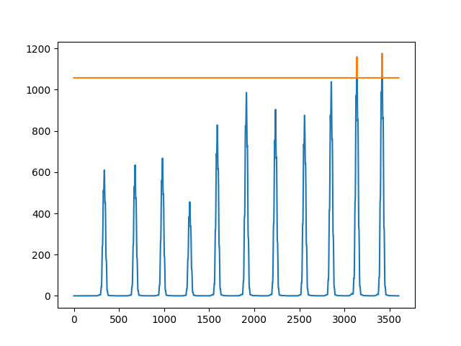

**4 ECG signal**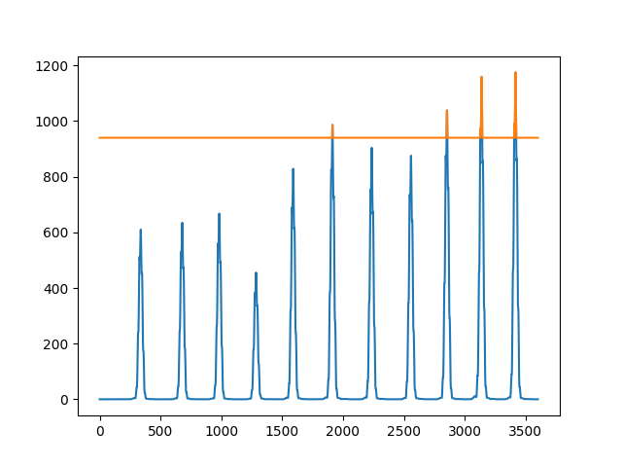

**And average heart rate by keeping the threshold as 0.5*max peak we get**

**Heart rate: 70.10710808179162 ppm**